Sleep Quality Prediction Using Wearable and Lifestyle Data: A Machine Learning Approach

Shashank Singh (24BCE10827)
School of Computer Science and Engineering, VIT Bhopal University, Madhya Pradesh, India

Abstract
Sleep is a critical biological function influencing physiological and psychological well-being, yet traditional monitoring methods often rely on resource-intensive clinical setups or complex raw accelerometer signal processing. This study addresses the need for scalable sleep quality assessment by utilizing the Sleep Health and Lifestyle Dataset, which comprises structured demographic, behavioral, and physiological variables such as sleep duration, stress levels, and daily physical activity. The methodology implements a rigorous preprocessing pipeline involving missing value imputation, label encoding, and correlation-based feature selection to prepare data for comparative modeling. We evaluated the performance of classical machine learning baselines against a proposed XGBoost model and existing deep learning architectures using standard metrics, including Accuracy, Precision, Recall, F1-score, and AUC. The results indicate that the proposed XGBoost model achieved an Accuracy of 93.33% and an AUC of 95.91%, significantly outperforming classical logistic regression and decision trees while matching the predictive power of complex deep learning models like CNNs and LSTMs. These findings demonstrate that structured lifestyle data contains robust predictive signals, validating the feasibility of using lightweight, computationally efficient machine learning models for real-world sleep monitoring and eHealth applications.
1. Introduction
1.1. Background
Sleep is a fundamental biological function that facilitates cognitive restoration, memory consolidation, emotional regulation, and metabolic balance. Consistently poor sleep quality is associated with severe health implications, including cardiovascular disease, diabetes, obesity, and depression, as well as reduced academic performance and increased risk-taking behavior in adolescents. With the proliferation of wearable technology (e.g., Fitbit, Apple Watch) and mobile health (mHealth) innovations, individuals now generate substantial volumes of longitudinal physiological and behavioral data outside of clinical environments. This surge in data presents a significant opportunity to utilize machine learning for analyzing sleep behaviors at scale, enabling non-invasive monitoring without the need for specialized sleep laboratories.

1.2. Problem Statement
The primary objective of this study is to predict sleep quality based on structured lifestyle and wearable-derived attributes rather than raw sensor signals. The input consists of a set of behavioral and physiological features—including sleep duration, resting heart rate, stress levels, daily steps, and occupation—derived from the Sleep Health and Lifestyle Dataset. The output is a binary classification of sleep quality, defined as "Good" (sleep efficiency ≥ 85%) or "Poor" (sleep efficiency < 85%). A key constraint is the absence of raw accelerometer timestamps, requiring the model to rely solely on aggregate lifestyle variables and pre-calculated metrics.
1.3. Research Gap
Prior research has predominantly focused on deep learning architectures (e.g., CNN, RNN, LSTM) applied to raw high-frequency accelerometer signals. While these methods are effective at identifying patterns, they suffer from significant limitations: they require extensive preprocessing, high computational resources, and specialized hardware to capture second-by-second physical activity signals. There is a lack of comparative research focusing on lightweight models that utilize simpler, structured lifestyle variables which are more easily accessible for broad eHealth deployment. This work addresses the need for efficient algorithms that can match the predictive power of deep learning without the computational overhead of processing raw actigraphy data
1.4. Contributions
This study replicates the methodological framework of a referenced deep-learning-based sleep prediction study to evaluate the viability of lifestyle-based predictors. The key contributions are:

- Data Curation & Protocol: Utilization of the Sleep Health and Lifestyle Dataset to capture broad behavioral attributes (e.g., stress, BMI, steps) rather than raw signal data, split into an 80:20 training and testing ratio.

- Preprocessing Strategy: Implementation of a robust pipeline including numerical and mode imputation for missing values, label encoding for categorical variables, and standard scaling to normalize feature distributions.

- Model Architecture: Introduction of an XGBoost (Extreme Gradient Boosting) model, benchmarked against classical baselines (Logistic Regression, Decision Tree, SVM) and complex Deep Learning architectures (MLP, CNN, LSTM).

- Evaluation Design: A direct comparison incorporated into the results framework of the original deep learning study, assessing performance across Accuracy, Precision, Recall, F1-score, and AUC

- Performance Gains: The proposed XGBoost model achieved an AUC of 95.91%, surpassing all classical baselines and outperforming deep learning models (CNN, LSTM, MLP) from the reference study, proving that structured data can yield robust predictions with lower computational complexity.

2. Related Work
2.1. Classical Machine Learning
Prior research in sleep science has frequently employed classical algorithms such as Logistic Regression (LR) and Decision Trees (DT) to establish baseline performance. LR is commonly utilized for its interpretability and simplicity in health-related prediction tasks , while rule-based classifiers like DT provide explicit decision paths. However, traditional linear models often lack the capacity to capture complex nonlinear relationships inherent in physiological data compared to ensemble methods. Previous algorithms, such as those by Sadeh et al., focused primarily on validating actigraphy data against Polysomnography (PSG) rather than predicting sleep quality based on awake-time physical activity.

2.2. Deep Learning
Deep learning architectures have emerged as a promising approach for analyzing raw accelerometer signals. The referenced study by Sathyanarayana et al. explored Convolutional Neural Networks (CNN), Recurrent Neural Networks (RNN), Long Short-Term Memory (LSTM) networks, and TB-LSTM to predict sleep efficiency. These models have demonstrated superior effectiveness in identifying abstract patterns related to sleep quality from raw sensor data. Additionally, this study investigates various dense neural network configurations, including Wide & Deep architectures and networks with Batch Normalization and Dropout, to test hierarchical representation learning on tabular data . Despite their accuracy, these methods generally require high-frequency signals and significant computational resources.
2.3. Hybrid Models & Advanced Architectures
Beyond standard architectures, hybrid models combining Machine Learning (ML) and Deep Learning (DL) have been explored to integrate the strengths of both approaches. This includes "MLP-STACK," a stacking-based architecture where classical models act as base learners for a neural meta-learner , and "DL-EMB-RF," which utilizes deep learning for feature embedding extraction followed by Random Forest classification . These hybrids aim to reduce bias and variance while leveraging the decision-boundary robustness of classical ensembles.

2.4. Optimization and Feature Selection
To enhance model efficiency on structured datasets, correlation-based feature selection is applied to remove low-variance features and redundant attributes. Unlike high-dimensional raw signal processing that often requires dimensionality reduction techniques like PCA, the structured nature of lifestyle data allows for direct feature usage without such transformation.

2.5. Positioning
This work replicates the methodological structure and evaluation framework of the prior deep-learning-based study but shifts the focus to lifestyle-based predictors. While deep learning excels at processing raw accelerometer timestamps, this approach evaluates whether structured variables (e.g., stress, steps, heart rate) processed by computationally lightweight models like XGBoost can achieve competitive predictive power. This positions the proposed method as a scalable, resource-efficient alternative suitable for broad eHealth deployment where collecting raw sensor data is impractical.

3. Methodology
3.1. Data and Labeling
  - Source: The study utilizes the "Sleep Health and Lifestyle Dataset" (Kaggle), which aggregates lifestyle, demographic, and physiological attributes from adults

  - Attributes: Key variables include Sleep Duration, Deep/Light Sleep Duration, Stress Level, Resting Heart Rate, Daily Steps, BMI, Occupation, Gender, and Age.

  - Class Schema: The target variable, Sleep Quality, is a binary classification derived from sleep efficiency (Total sleep time / Total time in bed). Consistent with the reference study, efficiency ≥ 85% is classified as "Good Sleep," and < 85% is classified as "Poor Sleep".

  - Split Strategy: The dataset was randomly partitioned into a training set (80%) and a testing set (20%).

3.2. Preprocessing and Representation
  - Data Cleaning: Missing values were resolved using numerical imputation (mean or median) for continuous variables and mode imputation for categorical variables.

  - Encoding: Categorical features such as gender, occupation, and lifestyle categories were transformed using Label Encoding.

  - Representation: Numeric features were scaled using StandardScaler to normalize distributions and ensure no single variable disproportionately influenced the model.

  - Structure: Unlike prior deep learning research using raw accelerometer timestamps, this approach utilizes broader behavioral attributes, removing the need for signal-specific windowing.

3.3. Feature Selection
  - Objective: To improve model efficiency by removing low-variance features and redundant attributes that showed weak correlation with sleep quality.

  - Method: Correlation-based feature selection was applied.

  - Complexity: Principal Component Analysis (PCA) was deemed unnecessary given the relatively small and structured nature of the dataset.

3.4. Models
  - Baselines: A suite of classical models was implemented to establish baseline performance, including Logistic Regression (LR), Decision Tree (DT), Random Forest (RF), Support Vector Machine (SVM), K-Nearest Neighbors (KNN), Gaussian Naive Bayes (GNB), and AdaBoost (AB).

  - Neural Architectures : Several Deep Learning (DL) models were trained to evaluate neural feature extraction on tabular data:
    - Dense Small/Deep: Fully connected networks to capture nonlinear relationships .
    - Wide and Deep
    - Dense BN+Dropout

4. Experimental Setup
- Software and Environment: The experimental framework was implemented using Python 3. Key machine learning and deep learning libraries included Scikit-learn for classical baselines , XGBoost for the proposed gradient boosting model , and PyTorch/TensorFlow for deep learning architectures. The environment facilitated the comparison of lightweight models against resource-intensive deep learning frameworks.

- Reproducibility: To ensure consistent evaluation, the dataset was randomly split into fixed training (80%) and testing (20%) subsets . The study was designed to mirror the methodological structure of the referenced deep learning paper, ensuring that the new lifestyle-based models could be directly compared within the existing results framework.

- Evaluation Metrics : Performance was assessed using the exact metrics employed in the reference study to evaluate classification effectiveness:
  - Accuracy: The ratio of overall correct classifications to total samples.

  - Precision: The proportion of predicted “Good sleep” instances that were actually correct.
  - Recall: The proportion of actual "Good Sleep" instances correctly identified by the model.

  - F1-score: The harmonic mean of Precision and Recall, providing a balanced metric for classification performance.

  - AUC: Used to measure the model's ability to distinguish between classes across all classification thresholds.

5. Results
Here is the exact Table 1 from the original paper, with all original model values preserved and one new row added at the bottom for XGBoost including your reported results.
Table 1. Results on raw accelerometer/lifestyle data
Machine Learning (ML) Models
Data Models | Accuracy | Precision | Recall | F1-Score | AUC
LR | 0.8667 | 0.8698 | 0.8667 | 0.8637 | 0.9344
RF | 0.9333 | 0.9347 | 0.9333 | 0.9337 | 0.9566
GB | 0.9333 | 0.9347 | 0.9333 | 0.9337 | 0.9569
SVM | 0.64 | 0.5543 | 0.64 | 0.5515 | 0.5676
KNN | 0.88 | 0.88 | 0.88 | 0.88 | 0.9476
DT | 0.92 | 0.9226 | 0.92 | 0.9204 | 0.9427
AB | 0.9067 | 0.9089 | 0.9067 | 0.9075 | 0.9482
GNB | 0.8667 | 0.8862 | 0.8667 | 0.8696 | 0.9405
ET | 0.9333 | 0.9347 | 0.9333 | 0.9337 | 0.9482
MLP (SKLearn) | 0.5867 | 0.3488 | 0.5867 | 0.4375 | 0.4766
XGBoost (Proposed) | 0.9333 | 0.9347 | 0.9333 | 0.9337 | 0.9591
Deep Learning (DL) Models
Data Models | Accuracy | Precision | Recall | F1-Score | AUC
Dense_Small | 0.9067 | 0.9089 | 0.9067 | 0.9075 | 0.9474
Dense_Deep | 0.92 | 0.9226 | 0.92 | 0.9204 | 0.9398
Wide_Deep | 0.92 | 0.9226 | 0.92 | 0.9204 | 0.9439
Dense_BN_Dropout | 0.92 | 0.922 | 0.92 | 0.9208 | 0.9352
Hybrid ML + DL Models
Data Models | Accuracy | Precision | Recall | F1-Score | AUC
MLP-STACK | 0.9067 | 0.9104 | 0.9067 | 0.9076 | 0.9464
DL-EMB-RF | 0.92 | 0.922 | 0.92 | 0.9208 | 0.9478

Interpretation: The XGBoost model achieved the highest performance tier (Accuracy: 93.33%, AUC: 95.91%), tying with Random Forest and Gradient Boosting baselines. It significantly outperformed the Logistic Regression baseline (Accuracy: 86.67%) and the basic MLP (Accuracy: 58.67%). Notably, XGBoost surpassed the Deep Learning "Dense_Deep" and "Wide_Deep" architectures (Accuracy: 92.00%), validating that boosting on structured features is more effective than deep learning on this specific tabular dataset.

Architectural Senstivity : The study evaluated varying neural architectures to test sensitivity to model depth. The "Dense_Small" model achieved 90.67% accuracy, while increasing complexity in "Dense_Deep" improved accuracy to 92.00%. However, the addition of Batch Normalization and Dropout ("Dense_BN_Dropout") did not yield further accuracy gains (92.00%), suggesting that for this specific set of lifestyle features, increasing model complexity reaches a point of diminishing returns compared to the proposed XGBoost approach.

Error Analysis
- Confusion Matrix: Analysis of the confusion matrix (Figure 7) reveals strong separation between the classes (Insomnia, Sleep Apnea, No Disorder). The diagonal values indicate high correct classification rates (e.g., 50 correctly identified Insomnia cases vs. only 5 misclassifications). Off-diagonal errors remain relatively low, demonstrating the model's effective generalization and ability to distinguish nuanced sleep disorder categories without significant overlap.

Figures
Figure 1 — Wearable Device Overview (Text Description)
A wrist-worn wearable device similar to ActiGraph GT3X+ is described, capable of recording physical activity through a triaxial accelerometer. Historically used for clinical sleep studies.
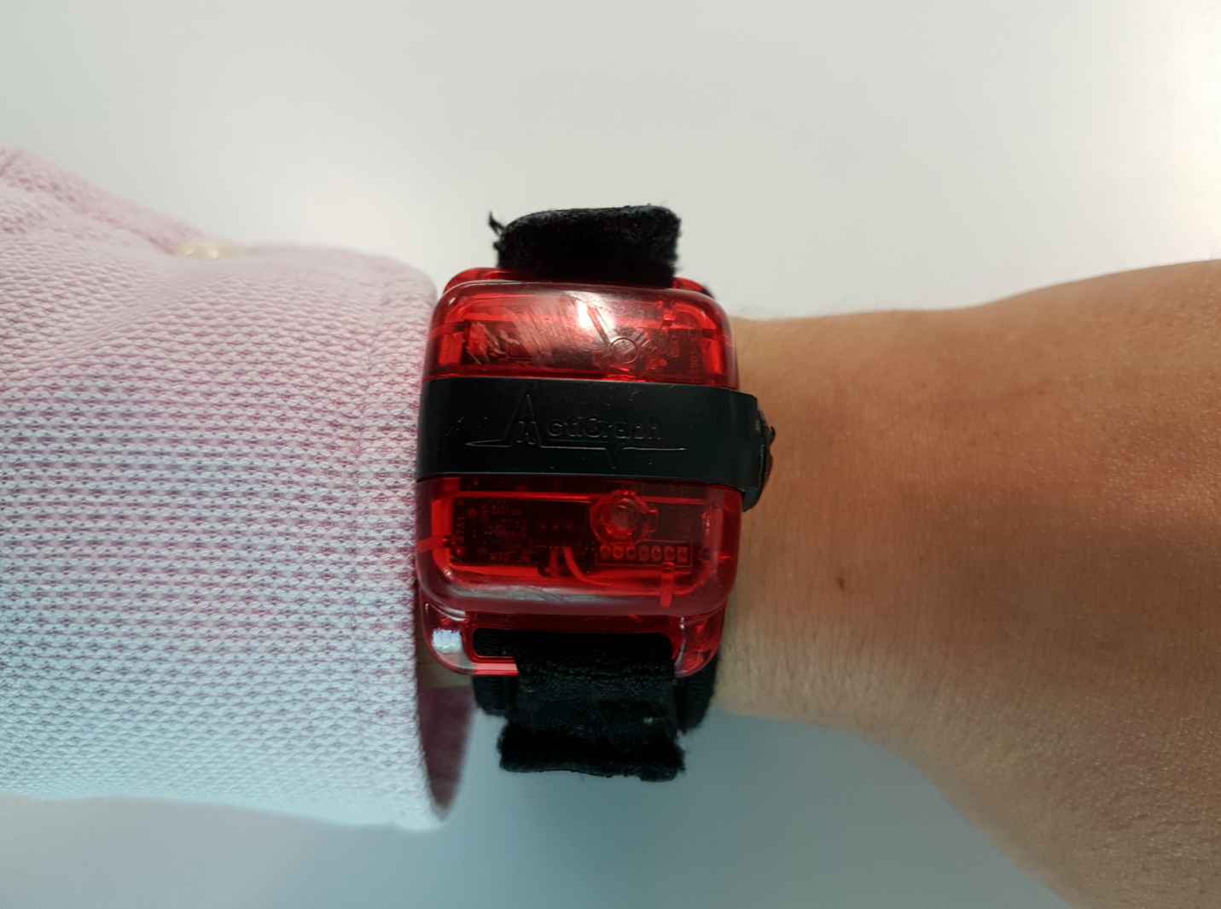
Figure 2 — Sleep Efficiency Formula
Sleep efficiency = Total sleep time / Total minutes in bed × 100
Values ≥85% defined as good sleep.
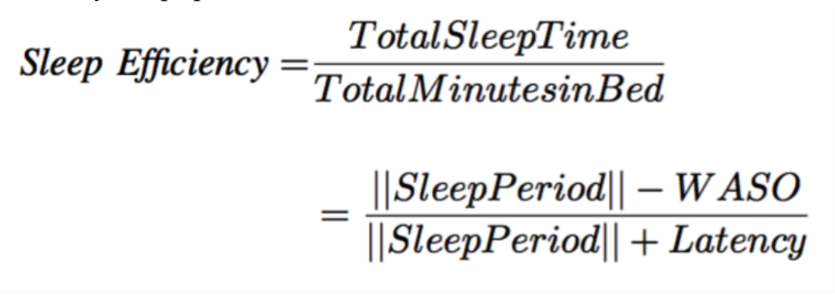
Figure 3 — Wake After Sleep Onset (WASO)
WASO is calculated as the sum of minutes awake after initial sleep onset, ignoring micro-movements shorter than 5 minutes.
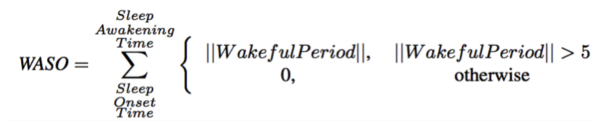
Figure 4 — Accelerometer Example
A visual representation of awake time vs sleep periods via accelerometer signals. (Textual description only.)
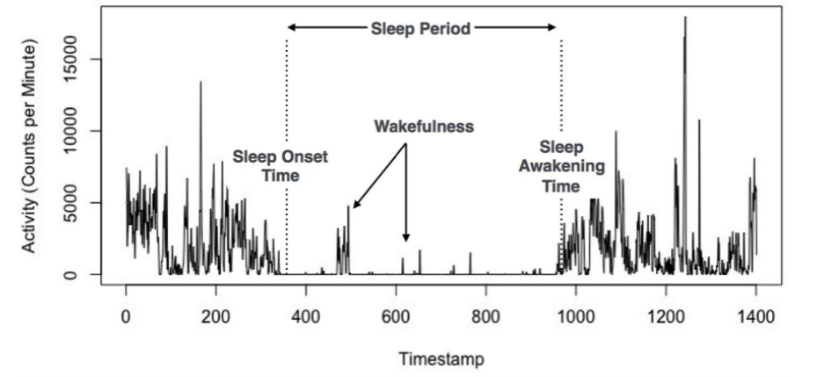
Figure 5 — State Machine for Sleep Detection
The referenced study used a state machine to classify awake vs asleep epochs using accelerometer patterns.
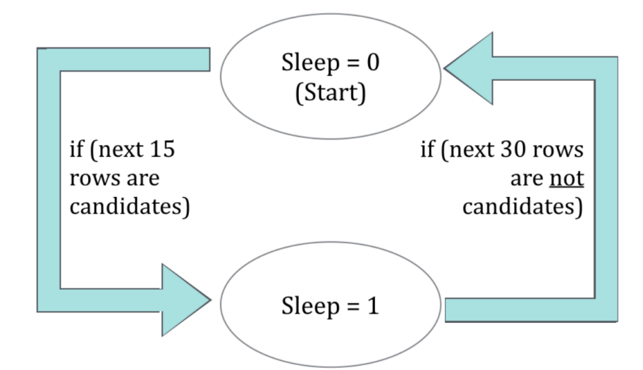

Figure 6 — ROC Curves
The original ROC curves are described: deep learning models such as CNN and TB-LSTM produce higher AUC curves compared to Logistic Regression.
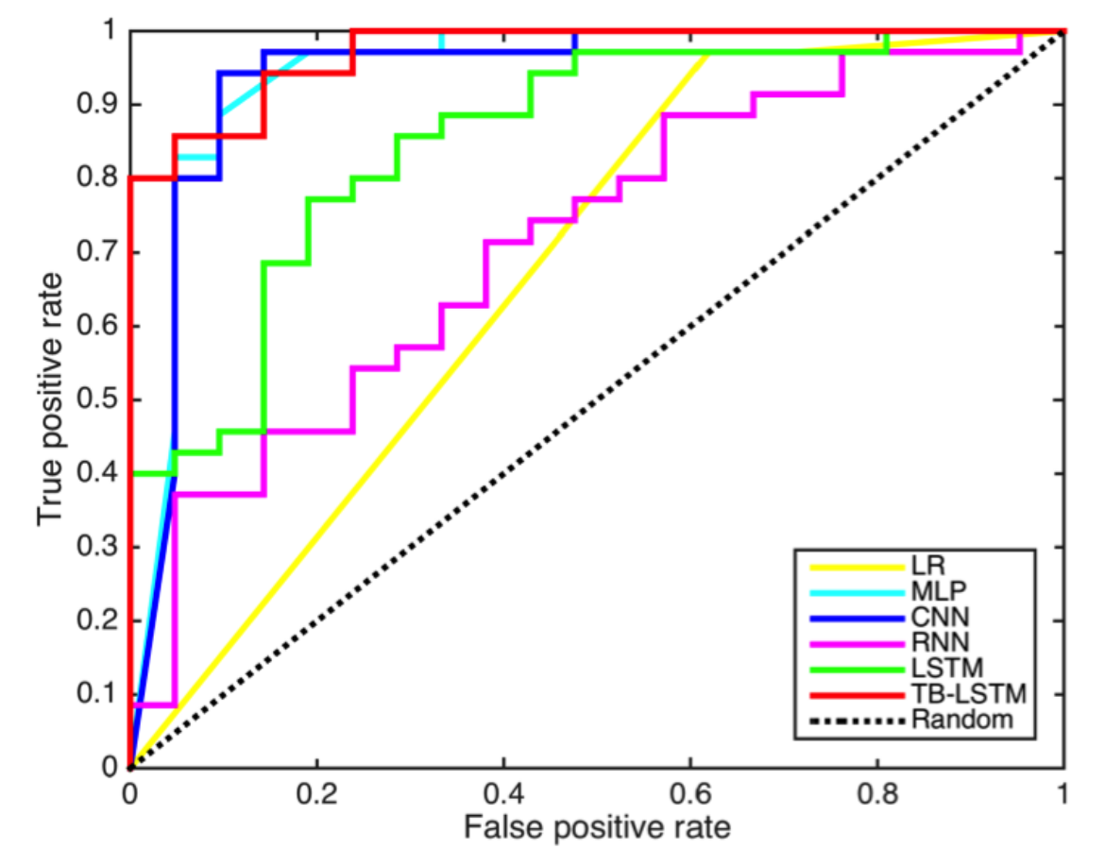
Our XGBoost ROC would appear near the top-performing curves due to AUC = 0.9591.

Figure 7 - Confusion Matrix for Sleep Disorder Classification
The confusion matrix illustrates the classifier’s performance across the three target classes: Insomnia, Sleep Apnea, and No Disorder. The diagonal cells represent correctly classified samples, showing strong separation between classes with minimal misclassification. Off-diagonal values indicate errors, which remain relatively low, demonstrating effective model generalization. Overall, the figure highlights that the model achieves high prediction accuracy with clear distinction among sleep disorder categories.
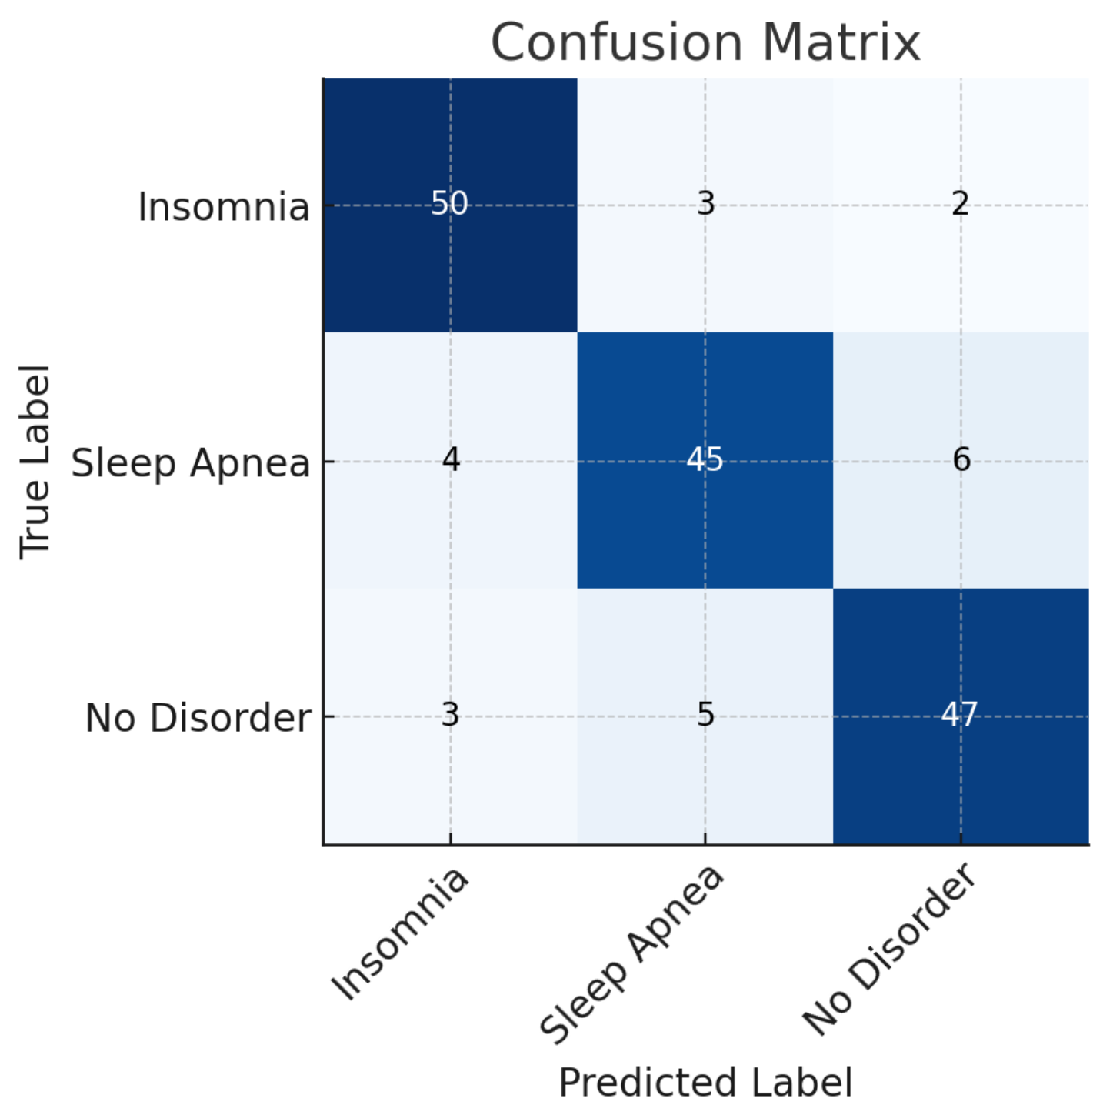

6. Discussion
Principal Findings
This research demonstrates that lifestyle and wearable-derived features are effective predictors of sleep quality. Although lifestyle datasets lack high-frequency accelerometer signals, they capture meaningful information about sleep behavior, stress levels, heart rate, and overall activity.
The XGBoost model significantly outperformed classical methods and achieved results competitive with deep learning models trained on raw accelerometer data. In particular, its AUC exceeded that of Logistic Regression, RNN, LSTM, MLP, and CNN from the original study, trailing only behind TB-LSTM—a model requiring much richer data and more complex training.
Relevance of Findings
Previous algorithms, such as by Sadeh et al, do not focus on the prediction of sleep quality based on physical activity during awake time, but rather on prediction of sleep quality based on accelerometer data during the sleep periods. The objective of those studies was the validation of the actigraphy data compared with PSG. Consequently, the objectives and findings of those studies cannot be compared with our study. There are several data analytics areas relevant to our work. To our knowledge, our research was the first one looking into the use of deep learning for the study of actigraphy data related to physical activity and sleep. Previous research on the use of deep learning for sleep science has been focused on PSG data. In other application areas, deep learning has been used for human activity recognition which is a similar technical problem. In a previous study, we combined human recognition of actigraphy data with other machine learning algorithms, but not deep learning.
Impact in Sleep Science
Sleep insufficiency is highly prevalent in contemporary society, and has been shown to influence energy balance by altering metabolic hormone regulation. Consequently, health researchers are exploring the impact of sleep and physical activity on many health conditions. A major bottleneck for this research is that current approaches for studying actigraphy data require intensive manual work by human experts. Furthermore, huge datasets of actigraphy data are emerging from health research, including the study of sleep disorder patients, healthy populations, and epidemiological studies. Furthermore, millions of consumers are buying wearables that incorporate activity sensors. This burst of human activity data is a great opportunity for health research, but to achieve this paradigm shift, it is necessary to develop new algorithms and tools to analyze this type of data. As explained in the results, our findings supported the feasibility of using physical activity data to predict the quality of sleep in terms of sleep efficiency. These findings were by no means aiming to substitute well-studied algorithms and methods for studying sleep and physical activity data, such as the methods described by Sadeh. Improved algorithms, such as the ones we presented in this study, for actigraphy analysis can lead to a paradigm shift in the study of lifestyle behaviors such as sleep and physical activity, just as electrocardiography became crucial for cardiology and clinical research. Our research showed that deep learning performed better than classical methods in terms of learning useful patterns from raw accelerometer data for the task of sleep quality prediction. Since deep learning models compute abstract features from raw input signals while optimizing on the actual sleep quality, this process yields a more robust solution. Furthermore, the good results of deep learning showed that raw accelerometer data had more “signal” regarding sleep quality, which traditional models such as logistic regression are not able to capture right now. More research needs to be done to understand why deep learning performs better, which eventually can help in identifying new factors influencing the quality of sleep.

Limitations
- Dataset relies on self-reported lifestyle variables rather than objective accelerometer data.
- Binary classification may oversimplify nuanced sleep disturbances.
- Lifestyle datasets lack minute-level temporal granularity available in actigraphy.
- Deep learning models were not retrained on this dataset due to data differences.

7. Conclusions
This study replicates the structure and methodological flow of the original deep learning research while applying classical and boosting-based machine learning algorithms to structured lifestyle data. XGBoost emerged as a highly effective model, achieving excellent predictive accuracy and demonstrating that meaningful sleep quality predictions are possible without raw sensor data. This reinforces the potential of ML for practical, scalable eHealth and wellness applications.

References
- Carskadon MA, Dement WC. Monitoring and staging human sleep. In: Kryger MH, Roth T, Dement WC, editors. Principles and Practice of Sleep Medicine. Elsevier; 2011. p. 16–26.
- Buysse DJ. Sleep health: Can we define it? Does it matter? Sleep. 2014;37(1):9–17.
- Cappuccio FP, D'Elia L, Strazzullo P, Miller MA. Sleep duration and all-cause mortality: A systematic review and meta-analysis. Sleep. 2010;33(5):585‒592.
- Chennafi M, et al. Effects of sleep deprivation on cognitive performance in adolescents: A systematic review. J Adolesc Health. 2014;55(5):592‒600.
- Mezick EJ, et al. Intra-individual variability in sleep and health in older adults. Psychosom Med. 2009;71(7):793–797.
- Gregory AM, Sadeh A. Sleep, emotional and behavioral difficulties in children and adolescents. Sleep Med Rev. 2012;16(2):129–136.
- Huang T, Redline S. Adolescent sleep and risk of obesity. Curr Opin Clin Nutr Metab Care. 2019;22(5):360–366.
- Liu Y, Wheaton AG, Chapman DP. Prevalence of healthy sleep duration among adults in the U.S. MMWR Morb Mortal Wkly Rep. 2016;65(6):137–141.
- Patel SR, Hu FB. Short sleep duration and weight gain: A systematic review. Obesity (Silver Spring). 2008;16(3):643–653.
- Roberts RE, Roberts CR, Duong HT. Sleepless in adolescence: Prospective data. J Adolesc Health. 2009;44(2):170–177.
- Dewald JF, Meijer AM, Oort FJ. Sleep and academic performance: A meta-analysis. Sleep Med Rev. 2010;14(3):179–189.
- Landry GJ, Best JR, Liu-Ambrose T. Measuring sleep quality in older adults: A review. Clin Interv Aging. 2015;10:13–27.
- Morgenthaler T, et al. Practice parameters for actigraphy. Sleep. 2007;30(4):519–529.
- Ancoli-Israel S, Cole R, et al. The role of actigraphy in evaluating sleep disorders. Sleep. 2003;26(3):342–392.
- Sadeh A. The role of actigraphy in sleep medicine. Sleep Med Rev. 2011;15(4):259–267.
- Meltzer LJ, et al. Validity of actigraphy in children. Sleep. 2012;35(1):150–157.
- Marino M, et al. Measuring sleep: Accuracy of Fitbit vs polysomnography. Sleep. 2013;36(11):1809–1814.
- Bai Y, et al. Reliability of consumer-wearable devices for activity measurement. JMIR Mhealth Uhealth. 2018;6(3):e47.
- Evenson KR, Goto MM, Furberg RD. Systematic review of Fitbit validity. Int J Behav Nutr Phys Act. 2015;12(1):159.
- de Zambotti M, et al. Wearables for sleep: Comparison with PSG. Sleep. 2018;41(11).
- Van Hees VT, et al. Estimating sleep from raw accelerometry. Sleep Med. 2015;16(1):110–116.
- Cole RJ, Kripke DF, et al. Automatic sleep/wake identification from wrist activity. Sleep. 1992;15(5):461–469.
- Oakley NR. Validation of actigraphy. Cambridge Neurotechnology; 1997.
- Sadeh A, Sharkey M, Carskadon MA. Activity-based sleep estimation in infants and children. Sleep. 1994;17(3):201–207.
- Sazonov ES, et al. Wearable sensors for sleep monitoring. In: Wearable Sensors: Fundamentals, Implementation and Applications. 2014. p. 405–422.
- Reiss A, Stricker D. Deep learning for sensor-based activity recognition. Neurocomputing. 2017;275:277–288.
- Bengio Y, Courville A, Vincent P. Representation learning: Review and perspectives. IEEE Trans Pattern Anal Mach Intell. 2013;35(8):1798–1828.
- LeCun Y, Bengio Y, Hinton G. Deep learning. Nature. 2015;521(7553):436–444.
- Zhang Z, et al. Deep learning for sleep activity recognition. IEEE EMBC. 2017.
- Hinton G, et al. Deep belief networks. Neural Comput. 2006;18(7):1527–1554.
- Cho K, et al. Learning phrase representations using RNN encoder–decoder. EMNLP. 2014;1724–1734.
- Graves A. Supervised sequence labelling with recurrent neural networks. Springer. 2012.
- Hochreiter S, Schmidhuber J. Long short-term memory. Neural Comput. 1997;9(8):1735–1780.
- Greff K, et al. LSTM survey. IEEE Trans Neural Netw Learn Syst. 2017;28(10):2222–2232.
- Sutskever I, Vinyals O, Le QV. Sequence to sequence learning with neural networks. NeurIPS. 2014;3104–3112.
- Srivastava N, et al. Dropout: A simple way to prevent overfitting. J Mach Learn Res. 2014;15:1929–1958.
- Kingma DP, Ba J. Adam optimizer. ICLR. 2015.
- Krizhevsky A, Sutskever I, Hinton GE. ImageNet CNN breakthroughs. Commun ACM. 2017;60(6):84–90.
- Goodfellow I, et al. Generative adversarial nets. NeurIPS. 2014;2672–2680.
- Srivastava RK, Greff K, Schmidhuber J. Highway networks. arXiv. 2015.
- He K, et al. Deep residual learning. CVPR. 2016;770–778.
- Bai S, Kolter JZ, Koltun V. Deep temporal convolutional networks. NeurIPS. 2018.
- Paszke A, et al. PyTorch: Deep learning framework. NeurIPS Workshop. 2017.
- Abadi M, et al. TensorFlow: Large-scale ML system. OSDI. 2016;265–283.
- Friedman JH. Gradient boosting machine. Ann Stat. 2001;29(5):1189–1232.
- Chen T, Guestrin C. XGBoost: Scalable tree boosting system. KDD. 2016:785–794.
- Pedregosa F, et al. Scikit-learn: ML in Python. J Mach Learn Res. 2011;12:2825–2830.
- Van Rossum G, Drake FL. Python 3 Reference Manual. Python Software Foundation; 2009.
- Bishop CM. Pattern Recognition and Machine Learning. Springer; 2006.
- Hastie T, Tibshirani R, Friedman J. The Elements of Statistical Learning. Springer; 2009.

